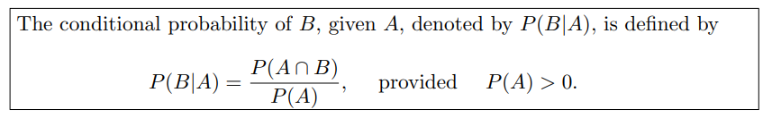

Example: The probability that a regularly scheduled flight departs on time is P(D)=0.83; the probability that it arrives on time is P(A)=0.82; and the probability that it departs and arrives on time is

P(D ∩ A)=0.78. Find the probability that a plane

(a) arrives on time, given that it departed on time,

(b) departed on time, given that it has arrived on time.

(c) arrives on time, given that it has not departed on time.

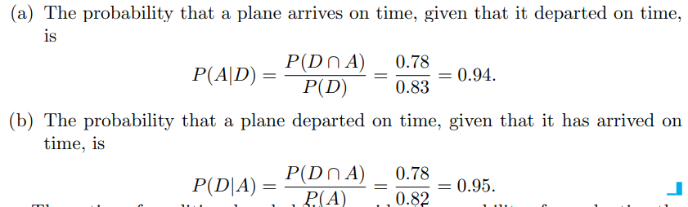

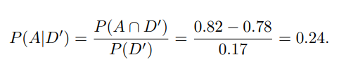

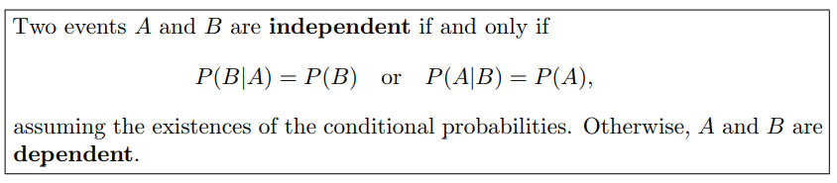

Q. Which of the following statements is/are correct?

(i) If events $A$ and $B$ are mutually exclusive then $P\left(A∩B\right)=P\left(A\right)P(B)$

(ii) If events $A$ and $B$ are mutually exclusive then $P\left(A∪B\right)=P\left(A\right)+P(B)$

(iii) If events $A$ and $B$ are mutually independent then $P\left(A∩B\right)=P\left(A\right)P(B)$.

(a) option (i) is correct only (b) option (ii) is correct only

(c) both options (ii)and (iii) are correct only (d) option (iii) is correct only.

Example: Suppose that we have a fuse box containing 20 fuses, of which 5 are defective. If 2 fuses are selected at random and removed from the box in succession without replacing the first, what is the probability that both fuses are defective?

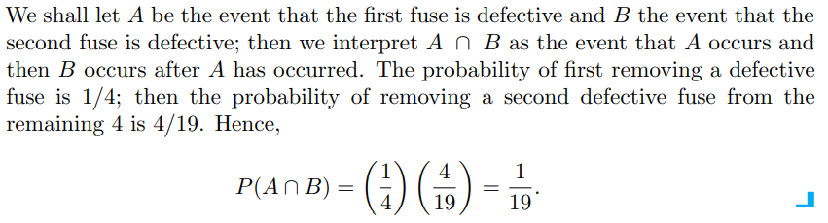

Example: One bag contains 4 white balls and 3 black balls, and a second bag contains 3 white balls and 5 black balls. One ball is drawn from the first bag and placed unseen in the second bag. What is the probability that a ball now drawn from the second bag is black?

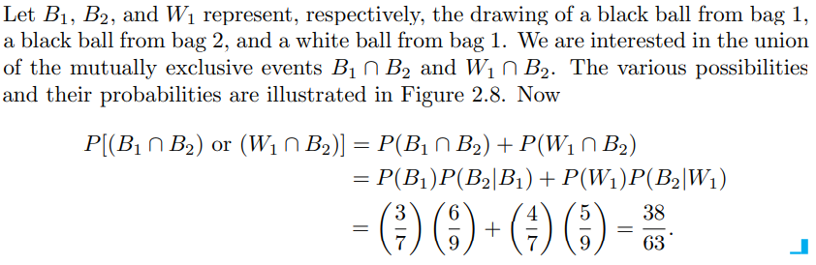

Example: An electrical system consists of four components as illustrated in Figure. The system works if components A and B work and either of the components C or D works. The reliability (probability of working) of each component is also shown in Figure. Find the probability that

(a) the entire system works and

(b) the component C does not work, given that the entire system works. Assume that the four components work independently.

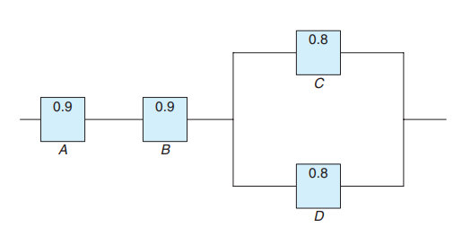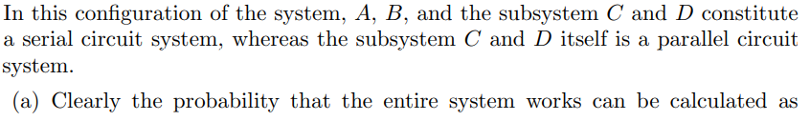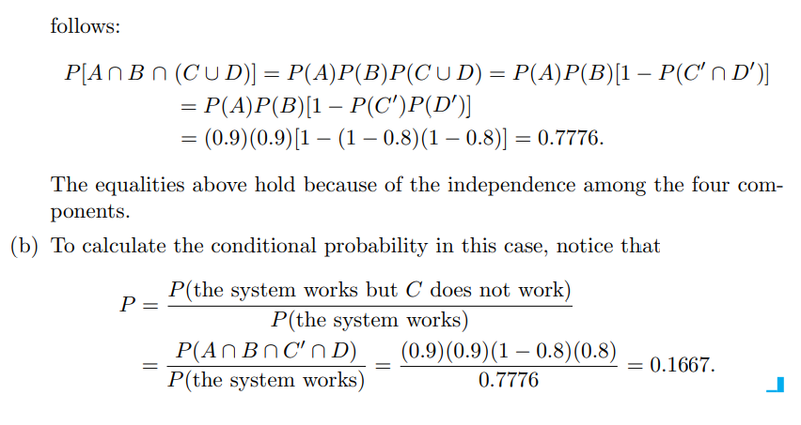

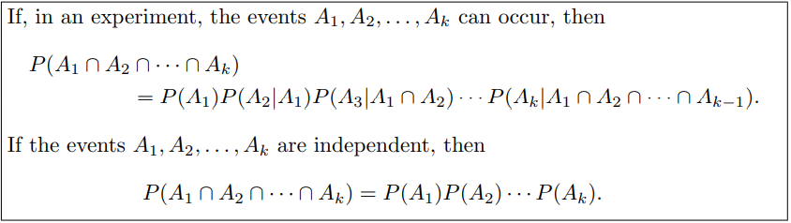

**Example:**

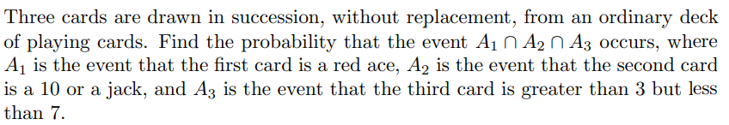

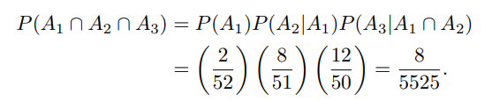

**Theorem of total probability or the rule of elimination**

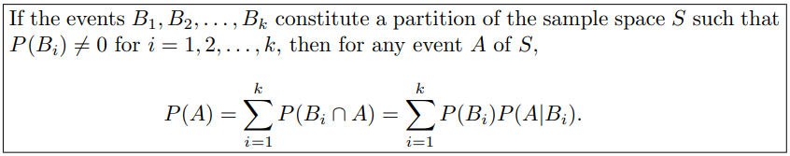

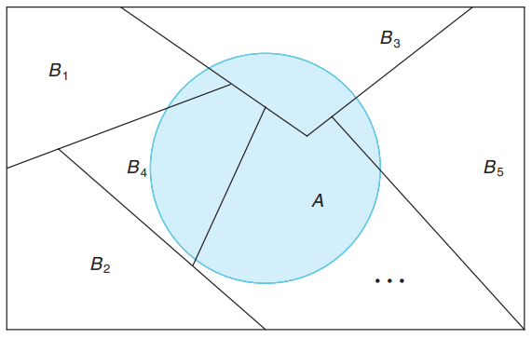

**Example:**

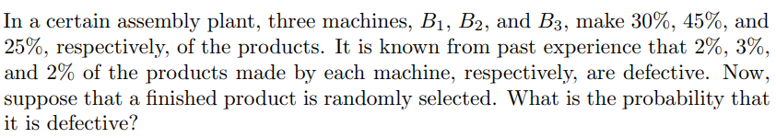

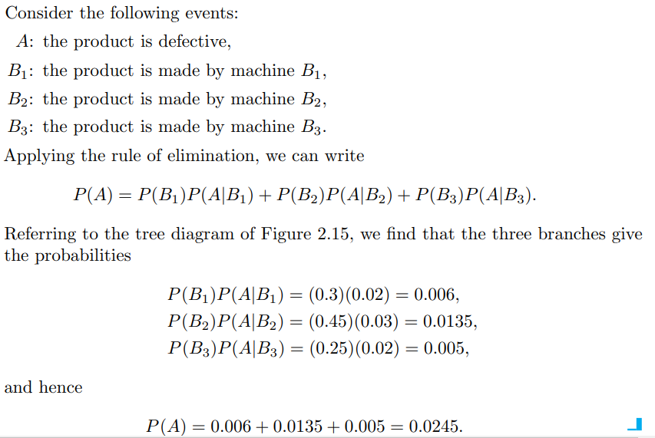 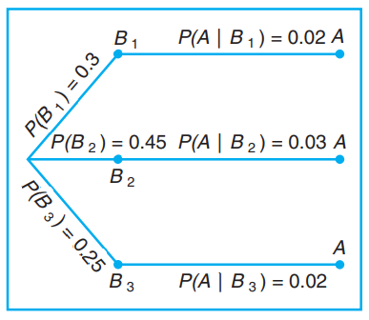

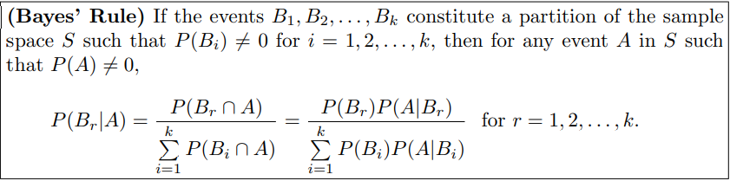

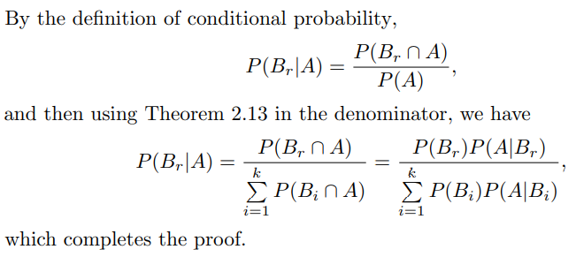

**Example:**



**If a product was chosen randomly and found to be defective, what is the probability that it was made by machine B3?**

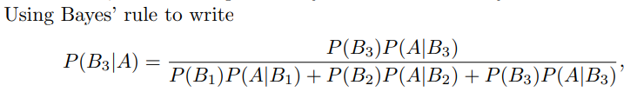 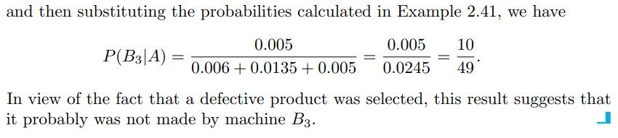

**Example:**

